Chapter III
System Design

System Design:
3.1. ER-Diagrams:
The Entity Relationship Diagram (ERD) depicts the relationship between the data objects. E-R diagrams represent the schemas or the overall organization of the system.
Constructing the basic model involves the following:
- Classifying data objects as either entities or attributes,
- Identifying and defining relationships between entities,
- naming and defining identified entities, attributes, and relationships,
- Documenting this information in the data document.
- Finally draw its ER diagram.

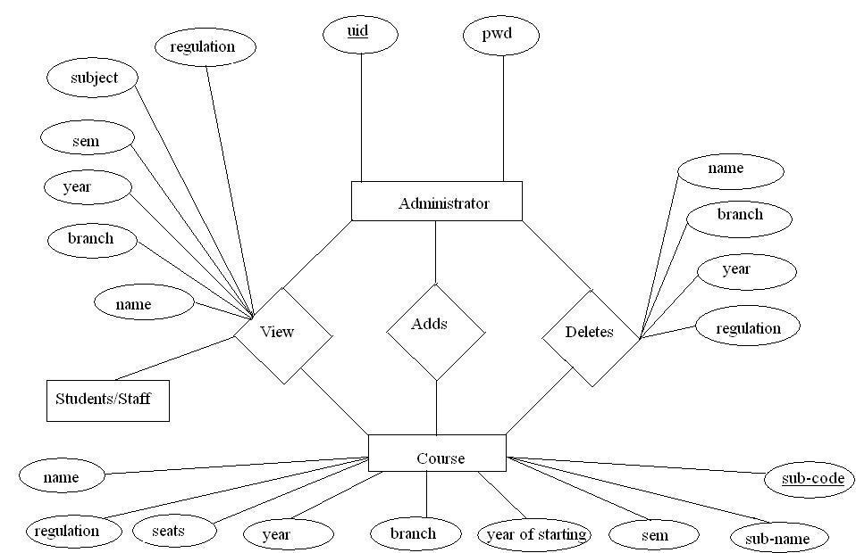

E-R Diagram Constructs:

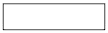 | ENTITY TYPE
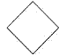 | RELATIONSHIP TYPE
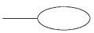 | ATTRIBUTE
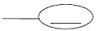 | KEY ATTRIBUTE

In the Course Management System, the following entities and attributes can be identified.
- Course -the set all the courses and their subjects in the college. Each course has a course name, branch, year, sem, subjects, year of starting and Regulation as its attributes.
- Administrator-the set all the library members. The member is described by the attributes login id, password.
- Student/staff-the set of all the students and staff in the college.
3.2. UML Diagrams:
UML is a general-purpose visual modeling language that is used to specify, visualize, construct, and document the artifacts of the software system.

Usecase Diagram:
A Usecase diagram shows a set of usecases and actors and their relationships. Usecase diagrams address the static Usecase view of a system. Usecase diagram consists of Usecase, actors, and the relationships between them.

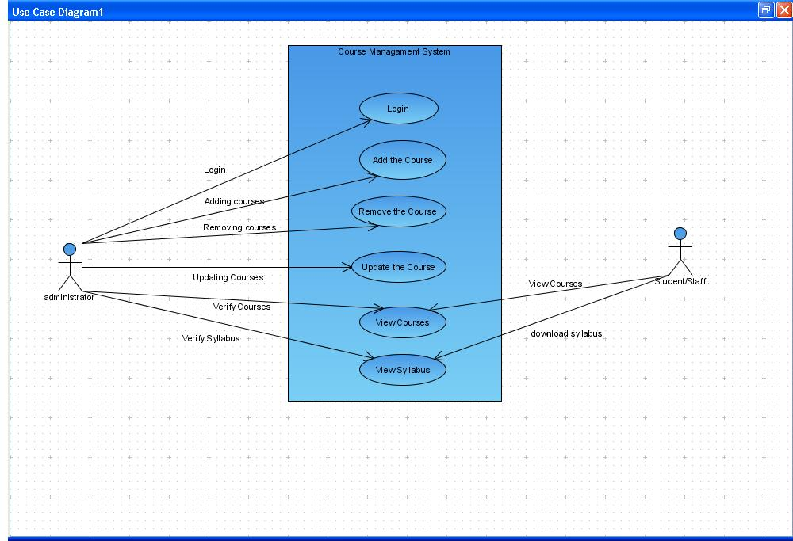

Class Diagram:
A Class Diagram is a type of static structure diagram that describes the structure of a system by showing the system's classes, their attributes, and the relationships between the classes.

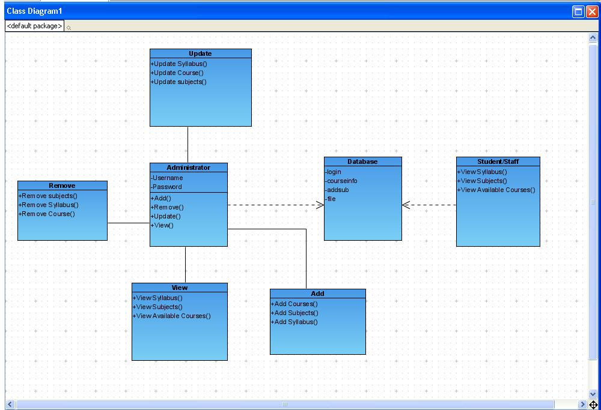

Sequence Diagram:
The Sequence Diagram is an Interaction Diagram that emphasizes the time ordering of messages for modeling a real time system.
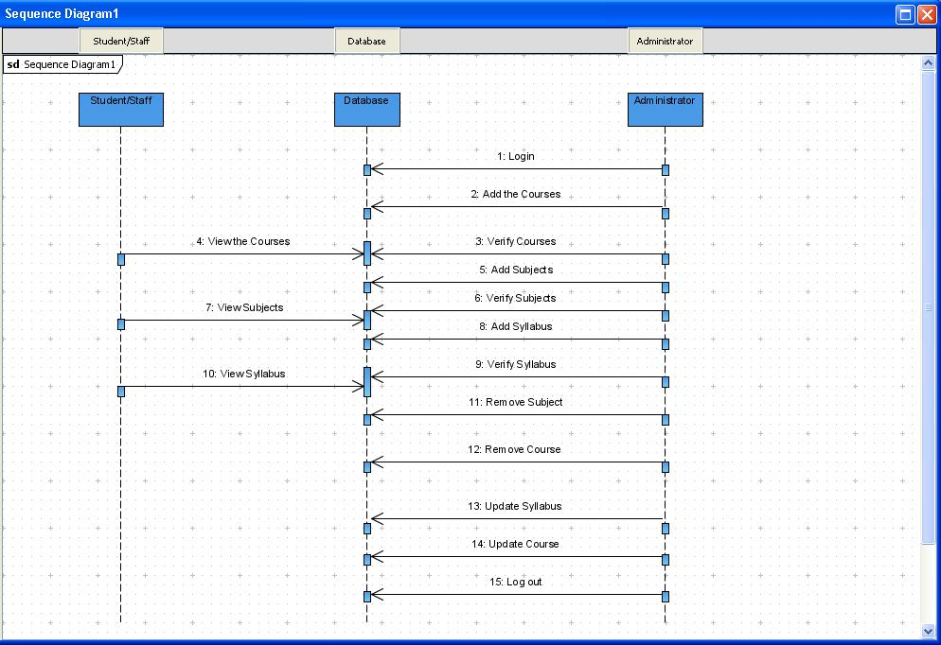

Activity Diagram:
An Activity Diagram is used to display the sequence of activities. Activity diagrams show the workflow from a start point to the finish point
